For this coin dispenser solution, I am using visual studio 2017 . First right click on the solution itself ,

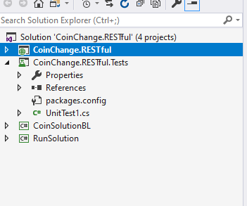

And set the Project , CoinChange.RestFul as the start up project so that when you click on the Run icon , the program can display the interface.

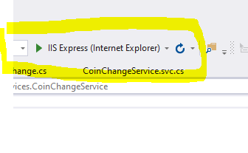

You can build by right clicking the solution 